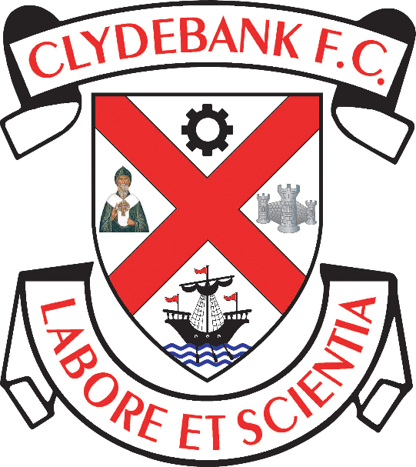

Equality Statement

Clydebank Football Club
Holm Park, Clydebank

Equality Statement
Clydebank FC is committed to remove and eliminate any direct or indirect discrimination of any form or kind within Clydebank FC’s structures, and will under no circumstances condone unlawful discriminatory practices.
The club takes a zero tolerance approach to discrimination, harassment, victimisation or bullying.
As the Chairman of Clydebank FC, I will be responsible for monitoring the implementation of the club’s Diversity and Equality Policy.
As Chairman I have overall responsibility for overseeing the delivery of the Equality Action Plan and the overall progress of Equality within the Clydebank FC’s structures.

Grace McGibbon
Chairman, Clydebank FC
May 2023

