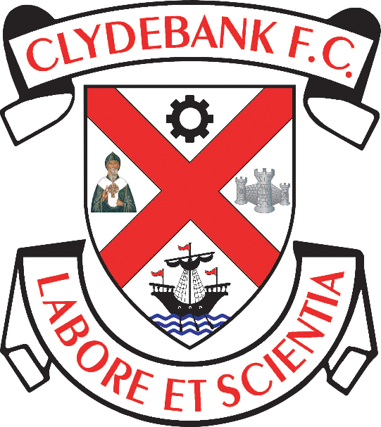

Spectator Safety Policy

Clydebank Football Club
Holm Park, Clydebank

General Policy:
- The Board of Directors of Clydebank Football Club (“the Club”) bear ultimate responsibility for the safe operation of the Club’s games and activities at Holm Park.
- The Club undertake to ensure that the premises and facilities at Holm Park are constructed, maintained and checked in such a way that the safety of everybody attending games at Holm Park is assured.
- The Club through its Safety Officer, officials and stewards will ensure the reasonable safety of those attending events at Holm Park.
- The Club will ensure that systems exist for the safe admission, accommodation and exit of spectators.
- The Club will undertake and maintain a process of risk assessment as required by the Management of Health and Safety at Work Regulations 1999 and will have regard to the assessment in formulating and updating this policy.
- The Club’s board will receive regular reports on the operation and implementation of the policy and its practical effects from the Safety Officer.
- Due to the changing nature of operations and facilities, the Club recognises that this Spectator Safety Policy is not a static document. The policy will be amended and/or added to when the necessity arises. Going forward, the policy will be subject to regular review as an agenda item of the Club’s board of directors’ meetings. The policy will be subject to a major review if changes to facilities or operations take place leading to a substantial revision of working practices.
- An investigation will be held following any major accident or incident involving spectators. The Spectator Safety Policy will be reviewed in the light of findings of the investigation.
- All outcomes of investigations, risks assessments and reviews will be shared with Holm Park Community Football Academy Limited.
- The Club’s Safety Officer will ensure that the policy is observed and that the Club operates in accordance with the relevant rules and regulations of West Dunbartonshire Council for the reasonable safety and well-being of all spectators attending Holm Park.
- As and when required the Club’s Safety Officer will liaise with Police Scotland, local Fire + Rescue, Scottish Ambulance service, and any other body in relation to safety at Holm Park.

Entry of Spectators
- The Club will ensure the provision of adequate entry systems to Holm Park.
- To ensure that capacities are not knowingly exceeded, entry to games expected to be near capacity will be “all ticket”.
- The Club will engage sufficient stewards to manage the entry of spectators prior to and during each event.
- The Club will engage sufficient segregation policies for home and away spectators as and when they are required.

Exit of spectators
- The Club will ensure the provision and maintenance of an adequate number of exits from the stadium to accommodate the maximum capacity of any area in use.
- All exits will be manned by stewards when Holm Park is in use for games and all such exits will be clearly identified.

Management of spectators in Holm Park
- The Club operates a system incorporating stewards to ensure the safety of spectators when entering and leaving Holm Park and whilst they are watching the event.
- CCTV is in operation of Holm Park and can be consulted, in real time or retrospectively, in identifying issues with spectators.
- Signs which govern hazards or relate to safety matters are placed prominently at all points of Holm Park.
- Any safety matters which are specific to any event will be conveyed to spectators at the event via the PA system, the programme or such other means as may reasonably be required.
- Matters which concern public order problems will involve liaison between the Club’s Safety Officer, officials and the police.

Stewarding
The main duties of the stewards are:
- To understand their general responsibilities towards the health and safety of all categories of spectators, other stewards, ground staff and themselves.
- To carry out pre-event safety checks.
- To control or direct spectators who are entering or leaving the ground, and to help achieve an even flow of people in, to and from the viewing areas.
- To assist in the safe operation of the ground, not to view the activity taking place, and to enforce Ground Regulations.
- To staff and steward entrances, exits and other strategic points; for example, segregation, perimeter and exit doors or gates which are not continuously secured in the open position while the ground is in use.
- To recognise crowd conditions so as to ensure the safe dispersal of spectators and the prevention of overcrowding, particularly on terrace or viewing slopes.
- To assist the emergency services as required.
- To provide basic emergency first aid.
- To respond to emergencies (such as the early stages of a fire); to raise the alarm and take necessary immediate action.
- To undertake specific duties in an emergency or as directed by the safety officer or the appropriate emergency service officer.
- Stewards must at all times be aware of and be ready to respond to the emergency procedures as set out in the Club’s Contingency Plan.

Inspection and Safety Reviews
- The Club will operate a system whereby all systems and equipment used as /part of its safety function are subject to continuous inspection and test.
- The frequency or inspections and tests will not be less than that advised by equipment manufactures or statutory requirements. Competent persons will be used to carry out such inspection or tests. The result of all inspections and tests will be recorded.
- The result of all inspections, tests, ongoing safety reporting and recording systems which make up the risk analysis, structural, mechanical and electrical surveys will form part of the annual policy review. Any certificates will be available for inspection.

Communication
With the public: The Club will endeavour to maintain communications with the public/spectators through information on its website, social media (Twitter and Facebook), in match programmes; club publications; public address system; encouragement of stewards in customer care and feedback from all sources both within and outside the Club.
With staff: The Club will encourage two-way communication with staff on all safety related matters. Staff will be encouraged to report all safety related issues through the chain of command at any time and a record will be made of all such comments.
With other agencies: When deemed necessary, the Club will provide facilities for both pre and post-match briefings between the Club and emergency or other external /services. The Club will endeavour to provide representation at the appropriate level for all meetings with such services. The Club will engage with appropriate local services in ensuring maintenance of best practice.

In the event of fire
- A fire alarm is installed at Holm Park
- In the event of a fire, the policies for evacuation and management of spectators and staff will be used. This policy is set out in the Club’s Contingency Plan.
- It will be the responsibility of the Club’s Safety Officer, officials and stewards to ensure proper evacuation of Holm Park in the event of a fire.

DOCUMENT CONTROL

Mandatory Review Date (to be reviewed and published annually)

Reviewed on 27/12/2021

Review Date: 27/12/2022

