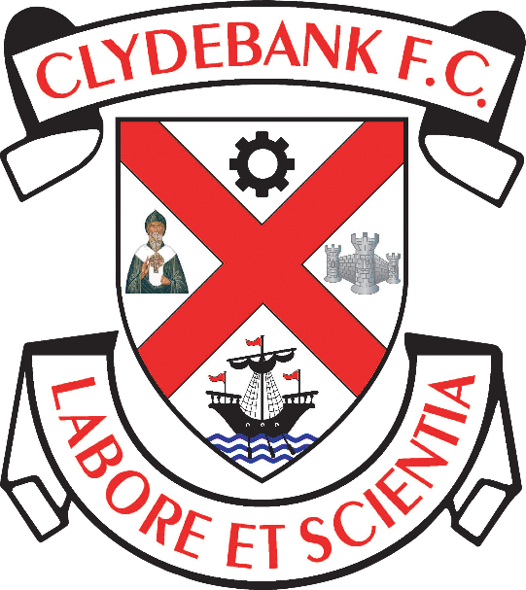

Social Media Policy

Clydebank Football Club
Holm Park, Clydebank

Purpose
Internet and mobile based social media platforms such as Facebook, Twitter, Instagram, YouTube, Snapchat, and any such similar currently existing or future existing sites, as well as personal blogs have become increasingly popular and like most modern businesses, Clydebank Football Club (“The Club”) is keen to ensure that its brand, employees, workers, customers and sponsors remain protected in what is a very open and public way of sharing information and images across the internet.

The principles within this policy remain consistent with the contractual obligations already in place for all employees/workers at the Club. This policy should be read in conjunction with your existing contract or letter outlining terms and conditions of your employment.

Legal Liability
The Club acknowledges that blogs and social networking sites provide individuals with a way of sharing their insights, expressing their opinions and communicating in a global environment. When you choose to go public with your opinions through a blog, social networking site or other openly accessible medium, you are legally responsible for those opinions. You should therefore be aware that you can be held personally responsible for any commentary deemed to be defamatory, obscene, discriminatory, proprietary or damaging (whether relating to the Club, other individuals or any other company – including the Club’s customers and sponsors). For these reasons, you need to exercise caution with regard to any derogatory, discriminatory or bullying remarks or characterisations, copyrighted materials, exaggeration or obscenity. In essence, what you post to the internet is at your own risk and other parties can pursue legal action against you personally for postings. Notwithstanding that you will be personally responsible for what you write or post, where what you post relates to your work (or work done by others at the Club), the Club may also be vicariously liable for what you say. You should also bear in mind that if you do anything outside of work which the Club considers is inappropriate given your role or position at work, you may be subject to disciplinary action by the Club in accordance with the Club’s Disciplinary and Grievance Procedures.

Protecting the Brand
The Club’s brand and media profile are exceptionally valuable assets which must be protected at all times. Use of the Club’s trademark logo, related brand images (including those of our sponsorship partners) and/or any other intellectual property owned by the Club when social networking or ‘blogging’ without the express consent of the Club is strictly prohibited. This includes photography of Club premises, employees, workers or ex-employees or workers, whether or not you own the copyright to any such images. You may post photographs that are in the public domain to the extent that they or the use to which they are put does not bring the Club into disrepute and provided always that your use of such photographs is not in breach of any other part of this policy. You must not post photographs which either as a result of your uniform, or location, identify you as a representative of the Club.

Care must also be taken to protect our employment brand and ensure absolute professionalism. You are reminded of your duty of confidentiality to the Club. You are expressly prohibited from posting anything to the internet or similar medium that might in any way bring the Club into disrepute. This includes ensuring there are no references to other football clubs and other clubs employees.

Confidentiality
During your employment/engagement with the Club, you will obtain confidential information in relation to, for example, the Club, associated businesses, employees, sponsorship partners, suppliers and customers. This information must not be shared with anyone, through any medium, for any reason (except in the proper execution of your duties) and must be kept strictly confidential, no matter how trivial it may appear. The internet is public domain and confidentiality must be maintained irrespective of any assurance that you may have been given as to local internet privacy arrangements for particular sites.
Absolute and unquestionable confidentiality must be maintained when dealing with information either directly or indirectly relating to the Club’s shareholders, their families and business interests.

Personal Data
For the safety of all employed or engaged by the Club, care must be taken in relation to the posting of personal data. Work based contact details must never be posted on sites used for non-work purposes.

Access
You are reminded that great care must be taken if you are accessing non-work related internet sites whilst at work and that access to certain sites is prohibited whilst at work.

Non-compliance with this Policy
Failure to adhere to the Social Networking and Blogging Policy may result in disciplinary action up to and including dismissal, depending on the circumstances.

This policy may be amended by the Club at its absolute discretion at any time.

BASIC / ESSENTIAL DO’S AND DON’TS

- Anything we say online – whether good, bad or indifferent – reflects upon the club and impacts upon its reputation
- Unless you have been specifically authorised by the Manager or Secretary you should not make comment on team news, injuries, trialists, closed door games etc
- Avoid getting involved in online chats or message exchanges with supporters – before you know it what you have said will be reported in another forum elsewhere
- The internet is a public space. If you wouldn’t say it to the Manager, a Director, a fan or a journalist, it’s best not to tweet it.
- Basically if you wouldn’t want your Mum or Granny to read it or see it, then best not to post it
- Any comment or photo you put out makes an indelible impression online – you might think you have deleted it, but it will be recorded and remain accessible
- You should inform the club if you have an account or are setting one up – if there are any problems we can assist you
- Above all else social media can be a great way to keep in touch with fans and friends and to raise your profile – enjoy it.

DOCUMENT CONTROL

Mandatory Review Date (to be reviewed and published annually)

Reviewed on 28/12/2020

Review Date: 27/12/2021

