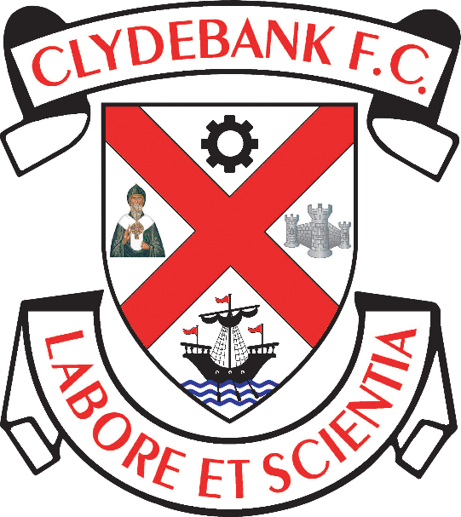

Supporter and Customer Charter

Clydebank Football Club
Holm Park, Clydebank

Introduction

Clydebank Football Club is a member of the West of Scotland Football League and the Scottish Football Association.

We recognise the commitment we owe to our supporters and the policies below lay out the Club’s continuing commitment to not only supporters but also to the wider community and the environment. This charter is designed to improve standards of customer relations between Clydebank Football Club and its supporters.

Supporter and Customer Charter

Clydebank Football Club (“The Club”) is committed to delivering the very highest standards of service to all supporters and customers.

The Club recognises the special bond between the Club and its supporters. It recognises and respects the invaluable contribution the supporters have made in the past and continue to make to the life of the Club. As such, the Club will make every effort to ensure that its policies and practices are open, accessible and communicated as effectively as possible with its supporters.

The Club will annually conduct a review of its Customer Charter, making changes in accordance with the recommendations put forward from the various groups and from guidelines received from the relevant governing bodies. The Club reserves the right to make amendments at short notice to this policy but all changes will be communicated to supporters through the Clydebank Football Club website.

Key Issues contained in this Charter

- Accessibility
- Matchday
- Membership
- Consultation and Information
- Community Activity
- Merchandise
- Staff Conduct
- Customer Service

1. Accessibility

Clydebank Football Club is committed to providing a high quality customer experience which is accessible to the widest possible audience.

1.1. Concessions are available for persons over 60 years of age and for junior supporters under 16 years of age. The Club may on occasions request proof of eligibility.

1.2. The Club will provide free access for carers looking after a registered disabled supporter.

1.3 The Club offers reduced admission to replays of abandoned games.
- If a match is abandoned after spectators are admitted to the ground, but before kick-off, spectators are entitled to free admission to the re-arranged match.
- If a match is abandoned after kick-off and before half-time, spectators are entitled to reduced admission to the rearranged match.

(In both the instances above supporters will be given a voucher/ticket upon leaving the ground which they must present at the rearranged game in order to qualify for any agreed discount)

- Admission reductions will not be given if a game is abandoned after half time.
- Refunds are not given under any circumstance.

1.4. The club will set admission prices for league games in line with the those set by the WoSFL. The Club however reserves the right to review admission charges and amend at short notice if necessary. If this happens supporters will be kept fully informed via the Club’s website.

1.5. Setting of admission prices for Cup-Ties is subject to the approval of the, WoSFL, SFA, Cup sponsor, and/or visiting club. The Club will also take account of the competition, status of the away Club and the stage of the Competition when determining Cup Tie prices.

1.6. Tickets will only be sold in advance for games for which a crowd of over 2,000 is
expected. Season Ticket holders will have the first opportunity to buy such tickets before they are made available for the general public. Consultation will take place with Away clubs to agree the ticket allocation which they will get allocated.

2. Matchday

At all times Clydebank Football Club will endeavour to provide a safe and enjoyable atmosphere for watching football.

2.1. The Club will provide a safe and trouble free environment for all spectators and shall ensure that the quality of service provided is of the highest standard possible.

2.2. Clydebank Football Club will provide an appropriate number of Stewards for all home games. These Stewards will be identifiable as they will wear high visibility jackets or waist-coats.

2.3. Clydebank Football Club will endeavour to make available hot and cold snacks for all home games.

2.4. Clydebank Football Club have produced a separate Spectator Safety Policy, Health and Safety Policy, Stadium Regulations, Contingency Plan and Stewards Code of Practice. These documents will be used by the Club to ensure spectator safety is of the highest quality possible during match days.

2.5. Any individual who is found to be in breach of the Ground Regulations are likely to be ejected from the Ground. In extreme cases the individual may face the withdrawal of their Season Ticket, banning from the Ground and potential prosecution under the Criminal Law (Consolidation) (Scotland) Act, 1995 as amended by the Crime and Disorder Act, 1998 or the Public Order Act, 1986.

2.6. In return the Club will expect all Spectators to refrain from foul and abusive language, taunts or gestures. In addition, racist or obscene behaviour of any kind will not be tolerated and any spectator finding an individual breaking these policies should contact the nearest Club Steward.

3. Membership

3.1. The Club is owned by the United Clydebank Supporters (UCS) Trust. The UCS Trust members elect a board of directors to run Clydebank Football Club. The Board will update all members each year of any significant developments at the club.

3.2. By paying the annual fee and agreeing to abide by the Trust and Football Club’s policies and codes of conduct, any person can be a member of the Trust.

3.3 Season Tickets will be on sale each season offering a discount on single purchase home league match admission. Season Ticket purchase does not confer membership.

4. Consultation and Information

Regular two-way communication with supporters, customers, suppliers, partners, shareholders, the media and the local community remains a priority focus for Clydebank Football Club.

4.1. The Club welcomes open consultation from its customers and welcomes all feedback, comments and suggestions. This can be conveyed to any committee member, sent to the Club in writing, or emailed to the following email address: info@clydebankfc.co.uk

4.2. The Club will give due consideration to all feedback, comments and suggestions implementing change where appropriate.

4.3. The Club will communicate regularly with Trust members, supporters and customers, informing them of new developments, policies, fixtures and price changes, promotions and new product launches. This will be done in the main through the Club’s official website, direct email, Facebook and Twitter accounts.

4.4. The Club will establish and maintain effective partnerships with all sectors of the media and will proved local newspapers with Club and squad information regarding new signings, man of the match photos, Club statistics and all other related articles of media interest.

4.5. The Club will maintain its official website www.clydebankfc.com with the latest information regarding match fixtures, cancellations, match reports, and all other related information.

4.6. The Club will publicise its position on major policy issues in the Club matchday programme, through the official Club web site, and where applicable through media releases.

4.7. The UCS Trust Board will advertise the date of the Trust annual general meeting in writing to all Trust members.

5. Community Activity

The Club recognises the role it can play in generating and supporting activity both in the local community and the wider football community.

5.1. The Club supports local charities and worthy causes allowing appropriate Matchday collections and working with local groups.

5.2. The Club supports local community and schools’ events that promote youth football and grass roots football.

5.3. The Club will support visits by charities carrying out events, organized in advance with the Club.

5.4. The Club will support pre-arranged Ground Tours to all interested parties and groups, especially school children.

5.5. Whenever possible and appropriate the Club will promote issues such as anti-racism, drug and crime. The Club supports the aims of leading initiatives such as ‘Show Racism the Red Card’ to tackle problems of racism in the game and has its own policy against racism.

5.6. The Club continues to support community events through visits and appearances of the Football Players and Management where possible.

6. Merchandise

6.1. The Club will publicise and advertise the dates of new replica kit introductions in advance of the scheduled launch date. Details of this launch date will be available from the website and other media releases.

6.2. Both home and away replica strip designs will normally have a life span of at least two seasons, unless changes are enforced due to contractual obligations, sponsorship issues, or availability of make\model of the strips.

6.2. The Club will only charge what it believes to be a fair price for the sale of replica kits and other associated merchandising items.

6.3. The Club will make available for purchase all Club merchandising on the official Club web site, or at the Ground on match days or at other suitable locations and times.

6.4. The Club will not knowingly buy goods from any supplier or manufacturer who does not comply fully with the labour, safety and other relevant laws of the countries of manufacture with respect to minimum wages, hours of work, overtime, sick pay and holiday entitlement.

6.6. Customers of Club merchandise who make purchase must agree to all terms and conditions of the sale and accept responsibility for following guidance relating to washing instructions.

7. Staff Conduct

7.1. The Club is committed to eliminating discrimination. We will not tolerate sexual or racially based harassment or other discriminating behaviour and will work to ensure that such behaviour is met with appropriate disciplinary action in whatever context it occurs.

7.2. It is the policy of the Club that there should be equal opportunity for all. This applies to external recruitment, internal appointment, terms of employment, conditions of service and opportunity for training and promotion regardless of sex, marital status, creed, colour, race, age, disability, sexual orientation or ethnic or national origin. The Club is committed to the development and promotion of such equality of opportunity. The policy also applies equally to the treatment of our customers, clients and suppliers. The Club has a separate Equal Opportunities policy and Disability Discrimination Policy.

8. Customer Service

All Clydebank Football Club Board members and personnel are responsible for ensuring that the very highest standards of customer service and customer care are maintained.

8.1. The Club respect the right of every supporter and customer to be always treated with the utmost courtesy and respect by all Clydebank Football Club personnel.

8.2. The Club strives to provide value for money in all areas.

8.3. The Club aims to respond promptly to any contact from a customer.

8.4. To avoid confusion Clydebank Football Club would prefer that all requests/complaints/comments or suggestions, are made in writing by letter or email. We will endeavour to provide a full response within 14 days.

8.5. In the first instance all correspondence should be addressed to the Club Secretary.

8.6. In the event that you feel your complaint has not been dealt with promptly or satisfactorily by the Club Secretary, you have the further right to progress directly through the Club Chairman, who has overall responsibility for the Customer Charter.

All correspondence should be addressed to the following;

Grace McGibbon
Chairman
Clydebank FC

DOCUMENT CONTROL

Mandatory Review Date (to be reviewed and published annually)

Reviewed on 28/12/2020

Review Date: 27/12/2021

