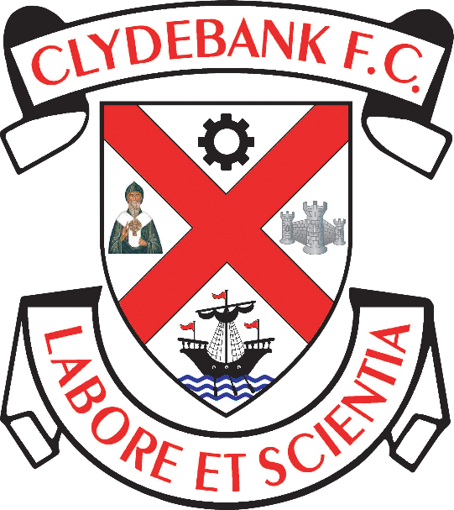

Unacceptable Conduct Policy

Clydebank Football Club
Holm Park, Clydebank

Clydebank Football Club will not tolerate unacceptable conduct from the Club’s employees, volunteers, Board members, players or supporters at Holm Park or at any other away football stadia.

We aim to create and maintain an environment where spectators can enjoy the game of football, safe in the knowledge that they are free from all forms of harassment, abuse, unacceptable or disorderly conduct including racism and sectarianism.

This policy applies for any football matches or events within Holm Park, Clydebank and to those associated with Clydebank FC when attending any football match.

We condemn racism in any form, either on or off the pitch. Clydebank Football Club aims to create and maintain a working and spectating environment free from racial harassment and abuse. Everyone connected with Clydebank Football Club has a responsibility to prevent racial harassment or abuse.

Any supporters (home or visiting) whose behaviour is unacceptable will face eviction from the ground and their actions will be reported to the police. Season ticket holders who conduct themselves in this manner face having their season ticket revoked and all spectators face the prospect of a life ban from Holm Park.

Everyone associated with the Club has a responsibility to prevent and discourage any form of abuse and as such are responsible not only for their own actions but also those of others. We would therefore encourage everyone to bring to the Club’s attention, any incident or behaviour, of individuals or groups of individuals, deemed to be in breach of this policy.

ANY PERSON ENGAGING IN UNACCEPTABLE CONDUCT MAY BE SUBJECT TO ANY, OR A COMBINATION OF THE FOLLOWING:

- Removal from Holm Park or away stadium
- Suspension from attending home matches involving Clydebank Football Club
- Indefinite ban from attending home matches involving Clydebank Football Club
- Suspension or ban from holding Clydebank Football Club membership
- Suspension or ban from the Clydebank Football Club Committee
- Suspension or ban as a Player or Coach from the Clydebank Football Club
- Report to the police and possible criminal proceedings.

Signed - The Board of Directors - Clydebank FC
DOCUMENT CONTROL

Mandatory Review Date (to be reviewed and published annually)

Reviewed on 28/12/2020

Review Date: 27/12/2021

