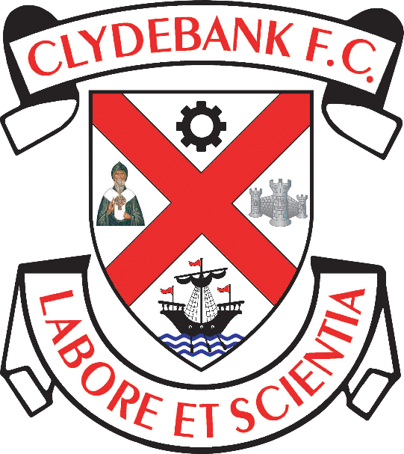

Diversity and Equality Policy

Clydebank Football Club
Holm Park, Clydebank

Clydebank Football Club is committed to the promotion of equality, inclusion, diversity and fair treatment in all its functions.

Clydebank Football Club does not tolerate discrimination, harassment or victimisation on the grounds of sex, race, disability, age, religious or political belief (including lack of belief), sexual orientation, marriage or civil partnership status, pregnancy or maternity, gender reassignment or social background.

We will therefore:

- Provide a welcoming environment for participants and visitors from all sections of the community, regardless of background or ability

- Commit to taking steps to develop a culture which prevents individuals, including members, officials, coaches, volunteers, staff or supporters being discriminated against on the grounds listed above

- Tackle any incidents of discrimination, harassment or victimisation that are brought to Clydebank Football Club’s attention

- Comply with our legal and moral obligations to eliminate discrimination, harassment and victimisation, and to improve equality in football

- Investigate complaints of discrimination or misconduct relating to alleged breaches of this equality policy. Where these are upheld, we will impose appropriate sanctions

- Pay due regard to the promotion of equality, diversity and fair treatment during the development and delivery of policies, procedures and actions

- Recognise and encourage diversity, inclusion and respect in our volunteers and staff, ensuring that we are equitable in our work with them

- Regularly review our policies and practices to ensure they pay due regard to equality

- Take steps wherever possible to increase the proportion of participants (including players, members, officials, coaches and volunteers) from under-represented groups, including through the use of positive action where appropriate

- Nominate a responsible person for overseeing, implementing and monitoring an equality policy with the Clydebank Football Club, ensuring members are aware of this point of contact in case of any concerns that the policy has been breached

- Review the policy in line with any legislation change or after every 3 years

DOCUMENT CONTROL

Mandatory Review Date (to be reviewed and published annually)

Reviewed on 28/12/2020

Review Date: 27/12/2021

As set out in the Equality Act 2010

